

## Table of contents

Table of contents 1

Introduction 2

Part 1 – The role of The Early Warning team, and its relationships within HP 3

A. HP, from a startup to a world-leading company 4

1. 73 years of growth, from the first steps of electronics to the advent of computing 4

a. Key dates 4

b. HP in Grenoble 4

2. Some figures 5

3. The actual organization of HP 6

a. HP organization 6

b. PSG EMEA 7

B. Early Warning 8

1. Within CSS 8

2. The programs led by the *Early Warning* team: scope, contacts, metrics and results 10

Part 2 – The eBuzz program: How to detect customer complaints on the internet 13

A. Presentation of the eBuzz program 14

B. eBuzz: daily tasks and improvement actions 16

1. Web monitoring and units captures 16

2. Improvement of the unit capture process 18

3. Improvement of the web monitoring tool 18

C. Achievements 18

1. eBuzz Process 18

a. Former tool: points to be improved 18

b. Actions put in place 19

2. eBuzz Tool 21

a. Former tool: points to be improved 21

b. Requirements for the new tool 23

c. Choice of the monitored forums 24

d. Choice of the structure of the new tool 25

e. Choice of the language and developing software 26

f. First versions of the new tool (Windev) 28

g. Second versions of the new tool (PHP-JavaScript): results 29

h. Global eBuzz results 32

i. Future improvements 32

Conclusion 33

Glossary 34

Table of Figures 35

Bibliography 36

## Introduction

This document is the final report of my End-of-studies internship that I performed between May and September 2012 within the Hewlett-Packard Company. This internship took place at HP Eybens site in Isère, France. I wished to perform this internship in the field of IT and new technologies, which have deeply altered our society in the recent decades.

This internship took place within a quality-dedicated team, in charge of the quick detection of quality deviations on HP latest models of PCs. The challenges that this team faces are really significant for HP. In fact, if a quality issue is detected soon enough, correctives actions can be introduced at the factory. The issue will therefore be avoided on dozens of thousands of units, and several millions of dollars of repairs can be saved.

This report consists in two parts. The first one explains and describes HP organization and environment, as well as the multiple connections of the team I joined. The second part is dedicated to the social media monitoring program I worked on, and presents my work and achievements.

Note

As almost all the communication within HP takes part of an international context, this whole report will be written in English.



# Part 1 – The role of The Early Warning team, and its relationships within HP

## HP, from a startup to a world-leading company

### 73 years of growth, from the first steps of electronics to the advent of computing

#### Key dates

From its creation in 1939 until today, HP has managed to grow and to innovate to become a world-leading IT company.

1939: William ‘Bill’ Hewlett and David ‘Dave’ Packard, two engineers in electronics, graduated from Stanford University, created with a capital of only $585 their enterprise. Its first offices were the own garage of David, in Palo Alto, California. Today, this garage has become a museum, and is commonly considered as the starting point of the Silicon Valley.

1940: Hewlett-Packard created a high-accuracy audio oscillator, more stable and 4 times cheaper than the existing models. The first 8 ones produced were bought by Walt Disney Pictures, and used for the sound effects of the Fantasia movie.

1940-1970: HP developed other measuring devices, which built the reputation of seriousness and of quality of the brand. Some radar jammers were also produced for the US Navy. At the early seventies, HP counts 1300 employees, and generated a turnover of 300 million dollars.

1972: The first scientific pocket calculator, the HP35, is launched. In a three-year period, more than 300 000 units were sold, at $395 each.

1973: HP marketed the first real time computer; the models of the HP3000 series will be sold up to 2003.

1981: HP sold since 1972 different models of pocket calculators. However, the financial pocket calculator HP12C encountered a stunning success. It is still produced almost identically, and is one of the computing products with the highest lifetime.

1984: HP entered the micro-computing market with its first PC and inkjet and laser printers.

1993: HP acquired Compaq, to strengthen its expertise in the PC market.

2010: HP acquired Palm, and entered the smartphones and mobility market.

#### HP in Grenoble

HP decided in 1969 to create its third European factory, in order to supply this growing market more easily. France was finally chosen as a location for this new plant, which would reinforce the two existing ones, in Germany and Scotland.

In 1970, HP was studying the applications of some cities of Brittany and Alsace to, which were supported by the French government, to host the new HP site. However, Hubert Dubedout, mayor of Grenoble, dismissed the procedures, and went directly in California to defend the application of Grenoble. Grenoble gathered all the required characteristics, and was logically chosen by the HP managers to host the new factory.

In 1971, HP began to transfer its technologies in France, and gave a second life to the myth of David Packard’s garage. In fact, HP set up temporarily its new factory in an empty hangar in Saint-Martin d’Hères. In the same time, the actual plot in Eybens was bought.

Two months after, the first HP computers manufactured in France left the temporary factory.

In 1975, the construction of the new buildings in Eybens ended, and HP increased its pace of production.

In 1975, a division fully dedicated to services is opened in HP Grenoble.

Between 1987 and 1992, HP entered the PC market, and Grenoble became the worldwide design center of these micro-computers.

In 2002, all the manufacturing activities are finally outsourced, and the Grenoble site is completely dedicated to services.

### Some figures

HP is today the leading provider of IT infrastructures, business and consumer solutions, software and services in the world. Even if HP headquarters are still located in Palo Alto, California, the company employs today around 350 000 people in 170 countries, responsible for ensuring the satisfaction of the billion people using HP technology every day.

In 2011, HP produced 52.3 million of printers (which represents half of the world’s market), 62.3 million of PCs, and is controlling a third of the worldwide servers market. In short, this means that 3.5 products are produced each second. From a services standpoint, HP is actually in charge of 200 datacenters, 380 000 servers, 5.4 million PCs and 17 million IP addresses.

Finally, HP turnover reached 126 billion dollars in 2010. Figure 1 shows the distribution of HP turnover during the first quarter of 2012.

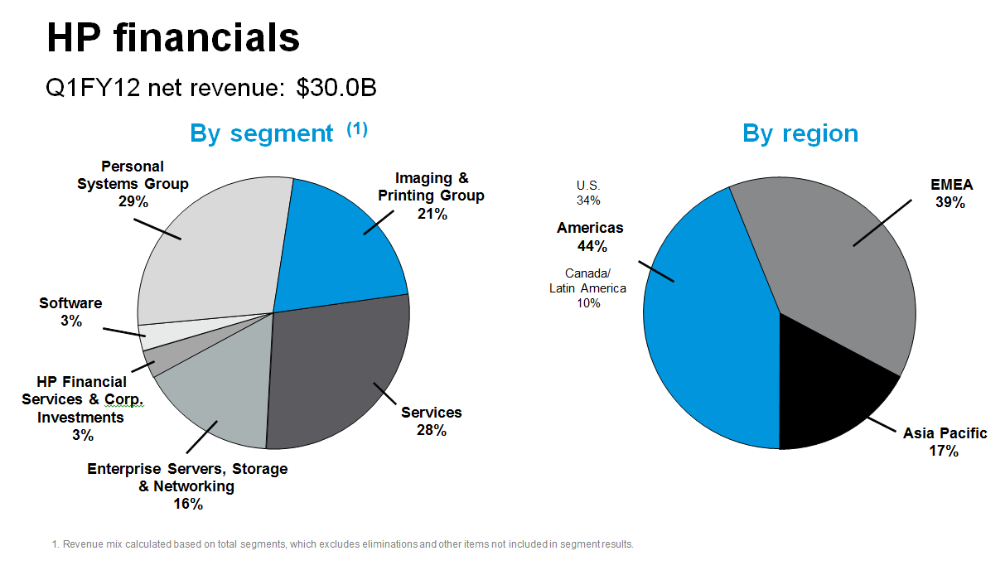

Figure - Breakdown of HP revenue by segment and by region (first 2012 quarter data)

### The actual organization of HP

#### HP organization

The company is split into Business Groups. The four main ones are:

* *PSG (Personal Systems Group)*, in charge of the PCs
* *IPG (Imaging and Printing Group)*, in charge of the printers
* *Enterprise*, in charge of the servers
* *Services*, in charge of the business services

There is also *Global Sales*, in charge of marketing, *Software and Financial Services*. Figure 2 summarizes the actual organization of the company.

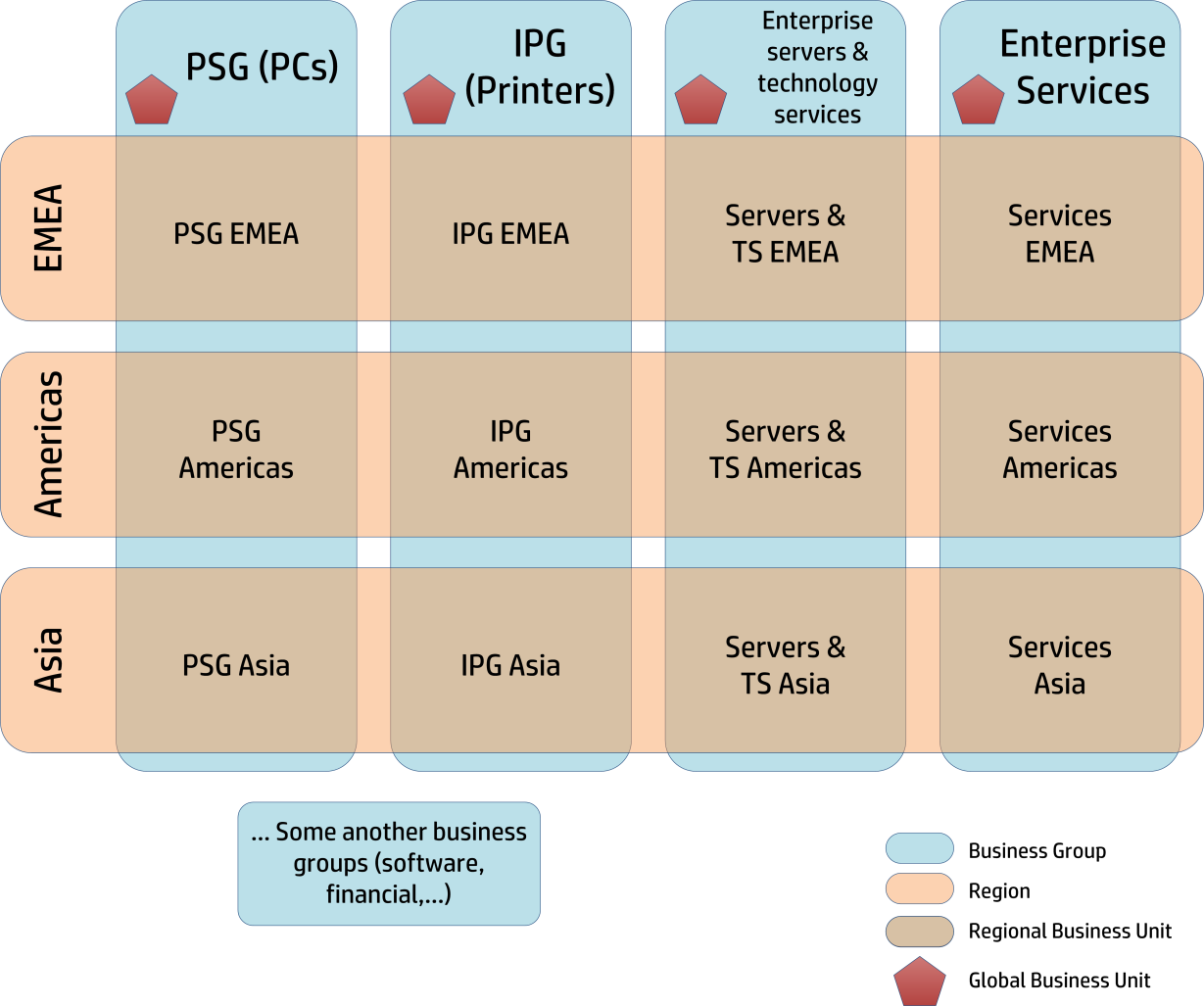

Figure - HP current organization

Each of the four main Business Groups is led by the *Global Business Unit*, or GBU. This GBU is at the head of the regional divisions of the Business Groups. Thereby, I made my internship within the PSG EMEA Regional Business Unit, in charge of the PCs for Europe, Middle East and Africa. PSG EMEA therefore reports to both the PSG GBU and the EMEA management.

#### PSG EMEA

As stated before, the PSG EMEA division is responsible of the PCs for the whole Europa zone. Its organization is divided – as shown on figure 3 (a) – in different functions. *Supply Chain* is in charge of all the manufacturing and delivery related aspects, while the *Category* team specifies the product lines and their specificities. The *Sales* team is in charge of sales and delivery, as well to private individuals (through the intermediate of resellers) and to businesses. As for the *Customer Support & Services* (CSS) team, it is dedicated to quality and support provided to the final customer. Some another additional functions complete the composition of PSG EMEA.

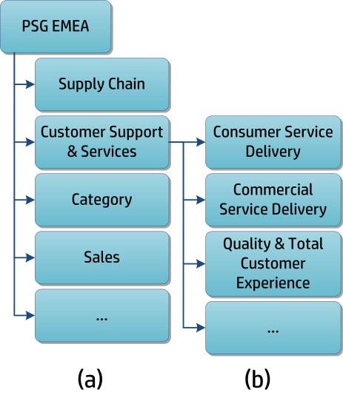

Figure - PSG EMEA partial organization

## Early Warning

### Within CSS

The team I joined during my internship is dedicated to the quick detection of quality issues on recent computers. Its role will be detailed in the continuation of this report. But we’ll begin by detailing the place of the *Early Warning* team within the PSG EMEA CSS service organization.

The organization of the Customer Support & Services team.

The *Customer Support & Services* team is mainly in charge of providing support to both private individuals and businesses (Consumer & Commercial Support Delivery). The second mission of the team is to monitor the quality of our products, and to ensure that the customers are satisfied with them. I made my internship within the *Quality Assurance & Total Customer Experience* team, which is dedicated to these quality concerns. The structure of the *Customer Support &* *Services* team is detailed on figure 3 (b).

The Quality Assurance & Total Customer Experience (QA&TCE) team

The QA&TCE team is in charge of the quality of the HP PCs sold in EMEA. This task is focused along two axes: reactivity and prevention. Indeed, on the one hand, the problems of the customers facing a quality issue must be resolved, and on the other hand, everything must be done to detect this kind of problems as soon as possible, and to avoid them in future. The QA&TCE team is therefore acting both upstream and downstream from quality issues. Its organization is detailed on figure 4.

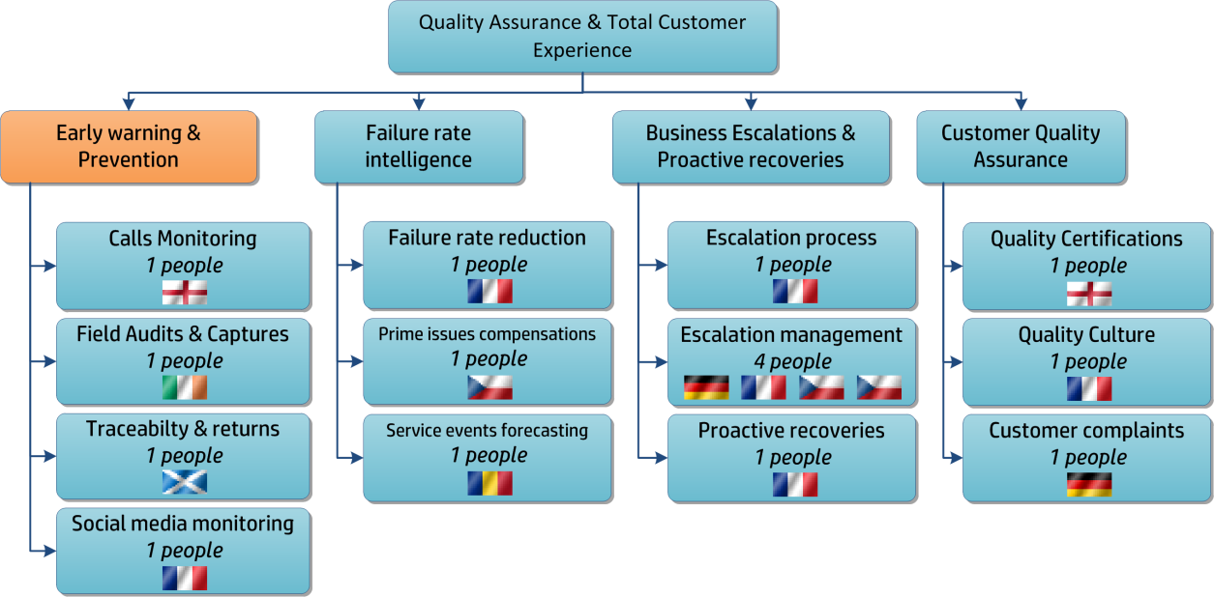

Figure - Organization chart and nationalities of the members of the QA&TCE team

It can be noticed that the members of the QA&TCE team are from 7 different nationalities (Czech Republic, England, France, Germany, Ireland, Romania and Scotland) and are working in 7 countries (Czech Republic, England, France, Germany, Ireland, Scotland and Switzerland). However, the sharing out is not as easy as it seems: the German are working in Switzerland and Ireland, the Irish and the English are based in Germany, etc…

The communication between the team members is thereby done by emails, phone conferences and online presentations. Obviously, almost all the communication is done in English, even between French people, to avoid needing to translate emails before forwarding them to another team member.

Let’s explain briefly the role of each sub-team:

* Early Warning: Detect as quick as possible quality issues, to limit their spread
* Business Escalations: Manage the escalations from corporate customers, which may place the potential future orders in danger
* Failure Rate Intelligence: Analyze and follow the evolution of different indicators, including the failure rate, to estimate the future costs of support
* Customer Quality Assurance: Develop the spirit of quality within HP, and make the customers aware of it

The missions of the Early Warning team

In the world of consumer PCs (the ones dedicated to private individuals), the life cycle of a product is very short, and lasts only a few months. After this time, the new products are already ready, and will replace the previous ones on the shelves of the shops. Thus, the paces of production are quite high, and if a defective part is integrated into PCs, most of the units usually have already left the factory when the quality issue is detected.

The mission of the *Early Warning* team is to lead different programs, intended to detect quickly the deviations in the quality of the products. To fulfill this task, the different programs use different information sources, and intervene at different steps of the product life-cycle.

### The programs led by the *Early Warning* team: scope, contacts, metrics and results

The 4 members of the *Early Warning* team are managing 7 programs detected to the quick detection of deviation in quality. These programs are each focusing on different phases in the product life. They are summarized in the figure 5.

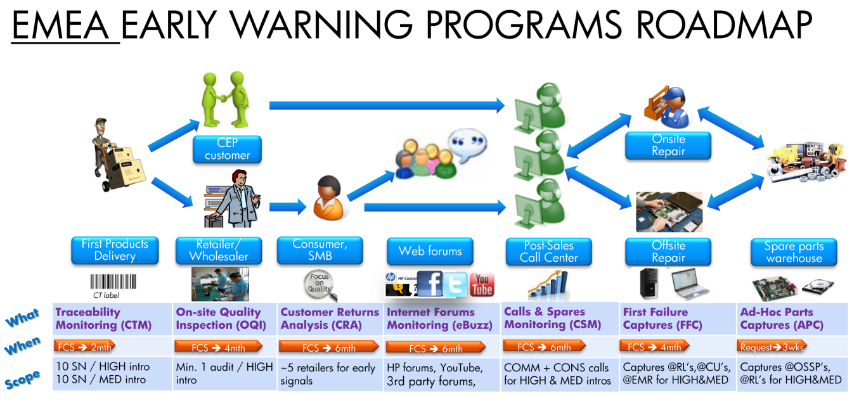

Figure - The programs led by the Early Warning team

With more details, these seven programs are:

* CTM (Commodity Traceability Monitoring): The goal of this program is to ensure that the traceability of all the commodities composing the units shipped to EMEA customers. Those commodities are the motherboard, the processor, the memory modules, the ODD, the HDD, the graphic card, the battery, the AC adapter, the display, the case, the keyboard, the network card, etc… To fulfill this objective, the CTM program checks a bunch of serial numbers for each of the new products, and verify if there is, or not, a gap in the traceability.
* OQI (On-site Quality Inspection): This program is the first to inspect units directly after they left the factory. The OQI program organizes some quality audits directly at customer, reseller or partner locations. The testing consists of unboxing the units, and then checking their cosmetic aspect as well as their basic functionality. Such audits also improve the relationship between HP and its customers. Indeed, the better way to secure the loyalty of a customer is to show him that we are hardly taking care of the quality of the products we sale, and especially of the products he bought.
* CRA (Customer Return Analysis): This program aims to analyze the causes of the units returned by the customers to their retailer, within the first months after the product introduction date, or FCS (First Customer Shipment). The CRA program is the first to get customer feedback, along the product cycle life. It also needs strong relationship and cooperation between HP and resellers.
* eBuzz: The aim of this program is to detect early feedback on product quality via social media sources. The sources currently monitored are the HP forums, Youtube, 3rd party computer forums, and online shops proposing customer reviews.
* CSM (Calls and Spares Monitoring): HP call centers are often the first port-of-call for customers having issues. It’s therefore an essential source of data to monitor. The CSM program allows identifying the leading symptoms that make customers ask for support. These main issues are then investigated, to understand their root cause and potentially launch corrective actions.
* FFC (First Failure Captures): This program aims to capture from the different EMEA repair lines the first failed units of each new model. Then, the failures encountered can be analyzed, and then quality improvement actions may be launched.
* APC (Ad-hoc Part Captures): This program is not really intended to detect potential issues. It is used only on the request of other quality teams, to capture defective parts, only to verify a supposed quality issue. The parts may be either commodities replaced on the repair lines, or EURP (End User Replaceable Parts), directly returned by the customer in exchange of spares.

To complete their objective, i.e. detecting quality deviation, successfully and efficiently, the *Early Warning* team members need the collaboration of many other teams within different HP organizations. These are for mainly:

* The traceability team, dedicated to develop the traceability systems, which have to solve the traceability problems detected by the CTM program.
* The category and sales teams, which helps to setup visit at customer location as part of the OQI program.
* The engineers of the 2nd level of support (2LS), which perform the inspections of the OQI program. They also take part of the eBuzz and CSM programs, by capturing faulty units or parts from the repair lines for further analysis.
* The supply chain teams, to investigate the root cause of the issues that may have been cause during the transportation of the units.
* The retailers, which provide for the CRA program data concerning the complaints of their customers.
* The PLEDGE team, and other HP teams dedicated to act in the social media. Even if these teams are more dedicated to study trends of the customer satisfaction, and to promote HP products, they can also discover some issues that may be of interest for the eBuzz program.
* The call centers, part of the 1st level of support (1LS), which provides interesting data to detect issues through the CSM program. The logs of the calls can also be used to confirm the existence of a potential issue detected thanks to the eBuzz program.
* The ODM (Original Design Manufacturer) and OEM (Original Equipment Manufacturer), which are, to put it simply, HP suppliers, which may ask the APC program manager to capture some parts for analysis.
* The engineers of the 3rd level of support (3LS), which are responsible for the analysis of the captured units. The will test them to detect the root cause of the problem, and then take the right decision with the *Supply Chain*, *Support* or *Manufacturing* teams to solve it, and/or to avoid it in the future.

To conclude, once a quality issue is suspected by one of the *Early Warning* programs, the capture of faulty units and/or parts is needed. These captures will enable HP to check if the problem is caused by a real trending deviation in quality, or by just a few parts unfortunately defective. The captures are made by the engineers of the 2LS (the ones which repairs the defective units), with the help of the 1LS (people answering in the call centers). Then the analysis of the captured units is either done by the 2LS engineers, who later forward the unit and their conclusions to the 3LS, or done directly by the 3LS. Finally the 3LS is responsible for the development of corrective actions to solve the issue on the affected product, or at least avoid its reappearance on the future ones.



# Part 2 – The eBuzz program: How to detect customer complaints on the internet

## Presentation of the eBuzz program

As explained in the previous part of this document, eBuzz is one of the *Early Warning* programs led within the EMEA *Customer Support and Services* team. Its main goal is to provide an early feedback on all the new PC products that have just been launched by HP. More precisely, eBuzz is intended to monitor all the desktops, notebooks, workstations and mobile workstations for 6 months following their FCS (First Customer Shipment) date.

The information sources that eBuzz is supposed to monitor are theoretically the whole internet, but, in fact, only the bigger social networks and computer-dedicated forums are worthwhile. Moreover, even if eBuzz monitors both consumer and commercial ranges of products, most of the findings concerns the products dedicated to private individuals. Indeed, businesses often have dedicated IT services or IT partners, which are on the one end able to solve a large amount of the problems encountered by the final users, and on the other hand dealing directly with HP call centers when they need some additional help. So, corporate customers will almost never complain on the internet forums.

Thus, when a certain amount of people complains about similar issues on the same model, it is likely that a real quality deviation occurred. It is then necessary to get some faulty units back from final users. This process is named capture. Indeed, spare units are supplied to these customers in exchange of their old ones.

Then, after getting back faulty units, the person in charge of the eBuzz program has to test these units, to reproduce the issue, and to determine its root cause. If needed, the analysis can also be done by the 2LS engineers. Then, the results of this first testing phase are forwarded, as well as the defective units, to the 3LS engineers. They are responsible for the complete diagnostic of the failure, and also for contacting the suppliers to set up corrective actions. However, it is necessary for the eBuzz program manager to follow the progress made by the 3LS. For example, in case that a software fix can be released to solve the problem, internet forums must still be monitored, to check if the fix is really efficient.

The final goal of the eBuzz program is in fact, as well as the other *Early Warning* programs, on the one hand to eventually reduce the number of failures and problems encountered by our clients, improve their satisfaction, and secure their loyalty, and on the other hand to reduce the costs involved in the whole support process, from the call centers to the repair lines. For example, in 2011, the savings enabled by the corrective actions put in place for the 179 issues detected by the *Early Warning* programs are evaluated to $4.7M.

As a conclusion, the figure 6 summarizes the whole main eBuzz process, from the introduction of a new product to the detection of an issue and the setup of corrective actions.

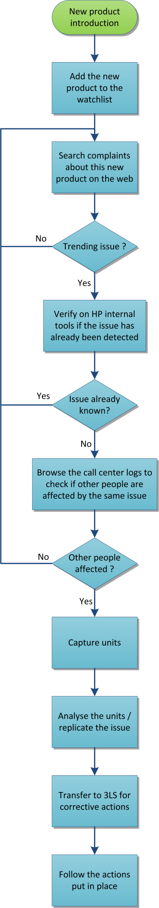

Figure - eBuzz entire process

## eBuzz: daily tasks and improvement actions

In this part will be detailed the objectives and tasks I was assigned to. Indeed, my mission on the eBuzz program was on the one hand to manage the program, and all its daily monitoring tasks, and on the other hand to improve it. This enhancement task can be split into two subtasks: first, the improvement of the capture process, to get more easily units back from the customers, and then, the amelioration of the tools and methods dedicated to identify issues on the internet.

### Web monitoring and units captures

Here will be described the necessary tasks that must be done continually for the eBuzz program. If one of them is not executed, the whole program is unable to detect any quality issues. This set groups together the following daily tasks:

Monitor new product introductions

Even if each HP employee receives from time to time emails from the marketing team, advertising and detailing one or two new products, the members of the *Early Warning* team are not directly informed of all new product introductions. That’s why a tracking sheet, named *roadmap* has been created. As soon as a team member find something about a new product, he updates the roadmap, and the 3 other team member have access to the same information. The information about the new products comes from different sources. The main ones are the marketing teams, the support category team (dedicated to define the support offer for each range of products, within and out the warranty period), and the demand planning team (which provide us the forecasted shipments for the next months). But gathering the information is not so easy; it may be found in the newsletter of each team, their SharePoint, or their internal websites.

Monitor the voice of the customers

This is the root task of the eBuzz program. Each day, as many forums and websites as possible must be browsed, to get the latest comments of new HP PCs buyers. This task was very time consuming at the beginning of my internship, that’s why it was one of the main points on which I focused my improvement efforts. This part of my work will be detailed later in this report.

Contact customers to get additional data

Many people are posting comments about their brand-new computer on many internet forums, which are both positive and negative. The problem here is that they hardly ever specify the exact name of their model. For example, they only speak about their *pavilion dv6*, when the exact name of their model is *pavilion dv6-6c25sf*. The *dv6* series exists for more than three years, and consists in more than 500 different computers. So it is often necessary to reply to the customer either in the original forum or by a private way, to get more information about the symptoms of the issue he is facing.

Browse the logs of the call centers

Once a potential issue identified and clarified, it is mandatory to evaluate the scope of the units affected by the same issue. This step is based on the logs of all the calls the call centers receive. This analysis must be done manually, because the troubleshooting steps, the language and the precision of the notes are always different. After having evaluated the scope of the issue, it may be useful to investigate further, and so to capture faulty units from the customer.

Capture faulty units

This is the task where the eBuzz program leader has the least control. His only work is to spot customers facing the same issue, and that just called the call center to get their unit repaired. After having forwarded this information to the 2LS people, some time is needed to let them contact the customer again, propose him an exchange rather than a repair, order the spare unit, get the customer unit back and send the new unit. And some of these steps can take time, and the difficulty to reach the customer sometimes avoids the capture of the unit. In fact, the unit may be repaired before we can propose an exchange to the customer. This step also needed improvement, and the amelioration I did will be described later in this report.

Test the captured units and escalate to the 3LS

This task was originally done by the 2LS people who managed to organize the unit capture, which tried to reproduce the issue the customer encountered. Then if the reproduction was successful, the unit and the first analysis are forwarded to the 3LS, in charge of determining the root cause. Here, the role of the eBuzz leader is only to provide the right contacts to everyone, and to ensure that the process in not stuck at one point. He is also responsible for the choice to escalate or not the issue from 2LS to 3LS. In this case, a detailed case must be created and documented in an internal tool called Impact.

Follow the 3LS investigations

Detecting issues that customers face is rather interesting, but this becomes useless if no precise investigation and no corrective actions are taken. So this is a need for the eBuzz program leader to follow the progress of the search for the root cause, and to encourage the implementation of corrective actions. These may either be the development of a fix, when it is possible, or the writing of guidelines for the design of the next new models.

All the tasks described above can take more or less time depending of the amount of potential issues detected on the web. But it gave me time to develop and improve some parts of this process.

### Improvement of the unit capture process

First of all, let’s explain the status of the eBuzz program when I took its lead. This program was launched only one year ago, and was developed by a part-time intern. He managed to design the whole process, and make everything work, but some points needing improvement were quickly identified. The first one was the process used to capture faulty units. Indeed, using 2LS resources to organize the capture of units, using information coming from the call centers wasn’t efficient enough. A lot of units were already repaired when 2LS finally managed to reach the customers.

To be short, the decision was made to focus on these three axes:

* Improve the finding of affected units, that can potentially be captured
* Simplify and speed up the capture process
* Ensure the efficiency of testing and issue replication

### Improvement of the web monitoring tool

The other point needing improvement was quickly identified too. The most time consuming task of the eBuzz program is the browsing of the monitored forums to find new issues. This task used to be done almost entirely manually, with the help of a little Excel macro opening webpages according to some search terms. It was conclude that the limitations of this macro were too strong, and that a new tool had to be designed. The three axes followed to develop this tool are:

* Monitor more forums and websites
* Automate as much as possible the search on the web
* Automate as much as possible the analysis of the collected data

The results of the improvements done on both the capture process and the web monitoring tool will be presented in the next part of this report.

## Achievements

### eBuzz Process

#### Former tool: points to be improved

Description

Before my arrival at HP, the identification of faulty units that can potentially be captured for analysis was based on the call center logs. An internal search engine is able to provide all the call logs related to a specific model of PC, within a defined time-range. These logs provide a good overview of all the customers who called support for a problem with this model of PC. Then, a manual sorting must be done to filter this list and keep only the calls related to the precise problem we want to investigate. Every call agent has a different manner to take his notes during each call, so this filtering step is rather time-consuming. Furthermore, the call agents often write their notes in their own language, so the sorting out sometimes needs to translate some notes.

Then the remaining call logs, which represent the potential units to capture, were sent to the engineers of the 2LS. Their mission is to check one by one the status of the units of all the selected customers. If the call agent and the customer agreed for a repair, we can contact back the customer between the pickup of its unit, and propose him an exchange rather than a repair. But our contacts at 2LS are mainly based in Bangalore, India, which is a problem to call back customers for example in France or Netherlands. They have to ask the local 1LS people, to call the customers at the right working hours and in the local language.

Once units have finally been captured, the testing was first done by the 2LS engineers, which tried to replicate the issue. But it wasn’t always easy to reproduce the right conditions and get the same symptoms. This used to be the case several times with issues related to Wi-Fi. Then if the issue can be reproduced, the unit was forwarded to the 3LS in the USA. Their engineers are indeed responsible for the root cause detection and the introduction of corrective actions.

Problems encountered

Although this process enabled to manage to capture faulty units, some points were detected as improvable. First of all, the complexity of the process (eBuzz → call logs → 2LS → 1LS → customer) made it slow. In fact, when 1LS finally managed to reach the customer, the unit was very likely already on the repair lines. We consequently lost a certain amount of possible captures at this time. The difficulty of the follow up of this process was also noticed. In fact, the eBuzz program leader only interacted with the 2LS people, and sometimes got no news during 2 or 3 weeks about these captures. After having discussed about this follow up issue with our contacts at 2LS level, it appears that they were also quite uncomfortable between us and 1LS, as they were also forwarding requests and mails from one side to the other. Finally, the point that the issue replication was sometimes unachievable was also noticed. In fact, the real cause is the lack of exact description of the conditions which generates the failure at customer’s side.

#### Actions put in place

To solve the problems with the capture process described below, the decision was made to investigate the possibility to capture units directly from eBuzz. This way has many advantages compared to the former process:

* Avoid multiple shipments (from customer to local 1LS, from local 1LS to 2LS in India, from 2LS to 3LS)
* Avoid multiple intermediates
* Speed up the capture process
* Have the ability to get directly explanations from the customer about the failure.
* Get the possibility to contact customers complaining on the web, and not only the one who contacted the call centers.

Nevertheless, introducing this new way to capture unit will require solving some additional aspects:

* Find people able to troubleshoot issues on the captured units: Indeed, as the units will not go through the hands of the 2LS people anymore, it is necessary to find someone able to test the units and to replicate the issues. At the moment, the investigation job I did on two units was efficient enough to identify the issue they were facing, so it was decided to assign me the testing mission. But my future departure from HP was considered too. In the case where the people that will be in charge of the eBuzz program don’t have the required testing skills, the units will directly be sent at 3LS for testing, and root cause identification.
* Be able to provide spare units to the customers: Obviously, customers won’t send their units back to HP until they get a spare one in exchange. Finding a way to provide a new spare unit to the customer is therefore necessary. After having investigated different ways, the choice was made to obtain these spare units from the *Customer Relation* team. This team will on the one hand contact HP resellers to get one spare unit, and then ship it to the customer, and on the other hand transfer the associated costs to the *Early Warning* team. Nevertheless, a few details still need clarification between us and the *Customer Relation* team.
* Get a process email: When contacting the customers, we will communicate them an email address. But to avoid receiving some spam on a personal address, a generic process address will be created, for example something like *ebuzz@hp.com*. The creation of such a mailbox is well documented and easy to achieve, it is usually activated within two days.
* Get a way to allow the customers to ship their faulty unit without having to pay anything: HP is contractually linked with DHL for all its shipments. So the best way to have the unit shipped back from the customer without fees for him is to provide him the number of a DHL account owned by HP. But even if this sounds easy, obtaining access to such an account is quite a long and hard process. The main concern is to have the allocation of the costs linked to the use of this account well organized and verified. This hard step is now completely settled.
* Ensure that the customer will really send back his faulty unit: For this point, a choice has to be done between these two options:
  + Wait that the customer ships his unit back to HP before sending him a new one.
  + Send a new unit to the customer and then wait that he ships back the faulty unit.

In fact, in the case we ship a new unit without waiting the old one, if the issue he encounters is not critical, the customer may be tempted to keep both two units. But if we wait to get the faulty unit before sending the new one, the customer will stay around 2 weeks without a computer. So, to avoid the refusal of the customer to get his unit exchange due to that delay, it was decided to give ‘trust’ to the customer, and to take the risk to ship the spare unit first, to offer him the better customer experience.

* Cancel the pickup and the repair of a unit, if the customer contacted the call center and gave his approval for a repair: If the customer contacted the call center, it is likely that he agreed to send his unit for repair. In this case, the repair has been scheduled, as well as the pickup of the unit. If we call the customer to propose him an exchange, it will be necessary to cancel both the repair and the pickup of his unit. This point is currently still under investigation.

### eBuzz Tool

#### Former tool: points to be improved

To facilitate the search for issues on the internet, an Excel-based tool was developed by my predecessor. This tool consists in three sheets, within the same Excel document. The first one was a list of all the monitored products, with all their information (codename, commercial name, First Consumer Shipment (FCS) date, product line, etc…). The second one was dedicated to a list of monitored forums topics. This is a list of topics which contain useful feedback, and which have to be frequently followed. Some additional information where stored here, like the number of answers to the first post of the topic, the date of the first post, the date of the last post, etc… Finally, a third sheet was dedicated to the monitoring of the forums. This sheet was in fact a big matrix of keywords and URLs of forums. A macro in this sheet, when activated, opened a search page, for each of the keywords, for the specified forum, in the default internet browser. The figures 7 to 10 display the different parts of the former eBuzz tool.

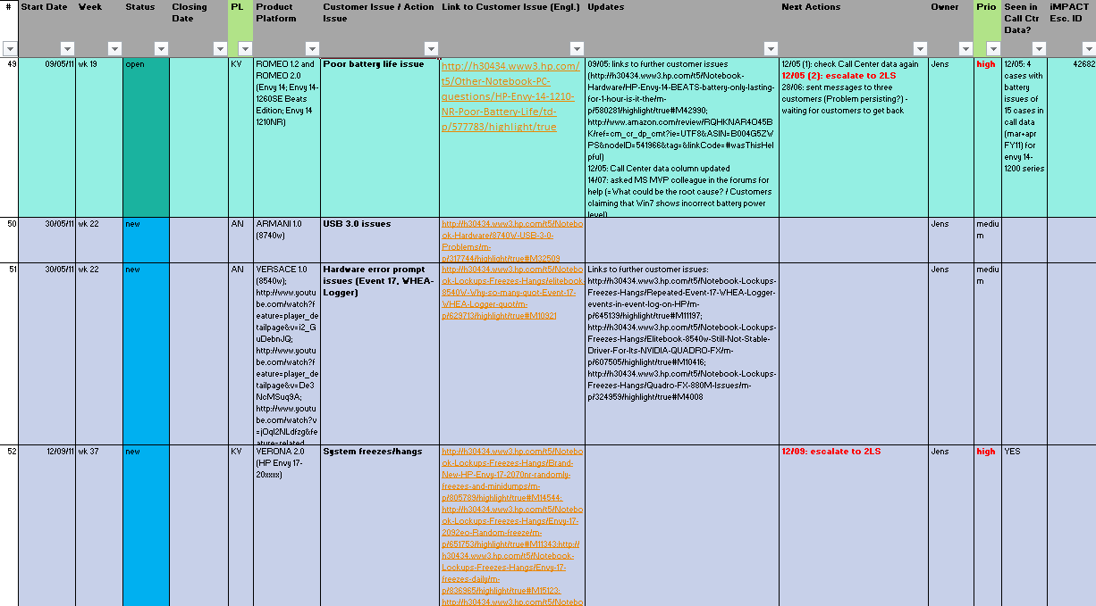

Figure - Former eBuzz tool: issue tracking sheet

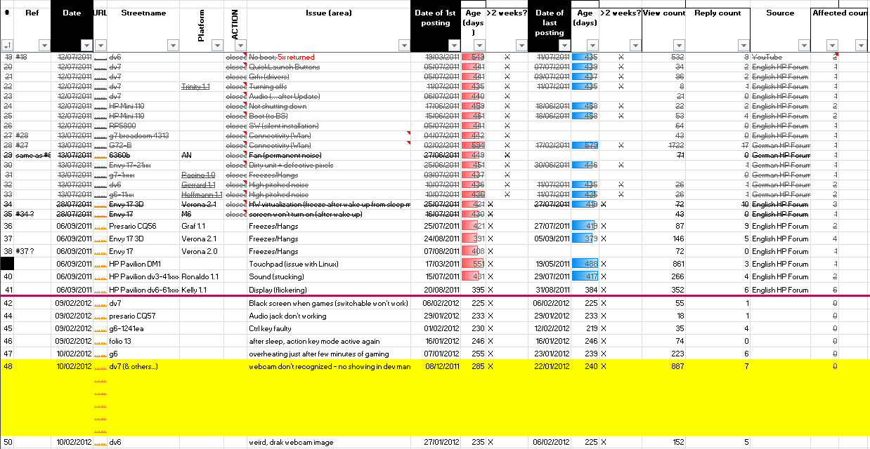

Figure - Former eBuzz tool: topic tracking sheet

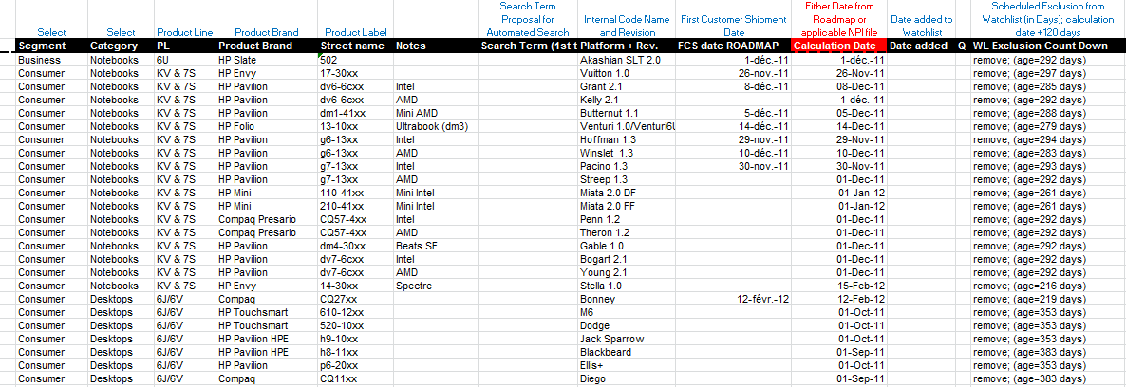

Figure - Former eBuzz tool: list of monitored products

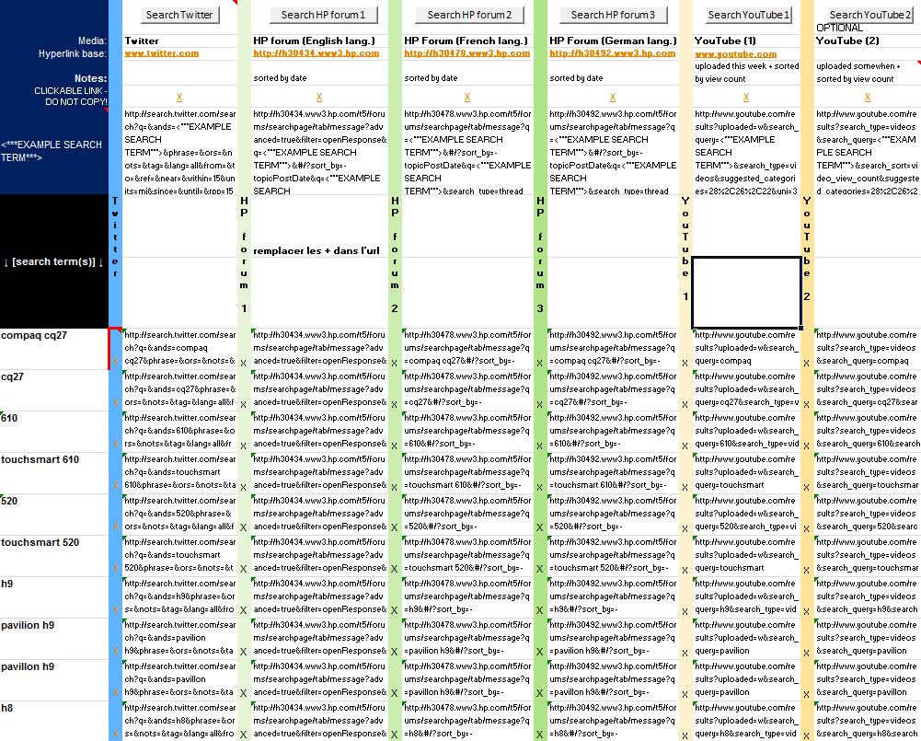

Figure - Former eBuzz tool: search sheet, opening several browser windows, according to search terms

The main issue with this tool was that, when looking for 30 different keywords, 30 different internet pages were opened. Furthermore, each of these search pages may link to dozens of topics, and the situation quickly became messy and confusing. Such a situation, with many browser windows opened, can also slow down the PC. Another negative point was that the list of keywords mixed all the products. It was impossible to only look for one or two products. The structure of the tool was also painful to update. In fact, if a read topic is identified as useful, it has to be manually added, with all its details, to the second sheet of the tool. This process was very time-consuming, and very likely to generate errors.

Finally, users almost never indicate the exact name of their products. They write for example *pavilion dv6*, instead of *pavilion dv6-6c23ef*. In fact, pavilion *dv6* is a series of more than 500 different computers. So the use of generic keywords like *dv6* is mandatory, but a lot of manual reading is needed to determine what the real unit of the customer is. Furthermore, the tool didn’t offer a possibility to separate the results provided by the exact keywords, for example *dv6-6c23*, from the generic keywords, which need further reading and checking.

This tool therefore needed a lot of improvement.

#### Requirements for the new tool

The four main enhancements that the old tool needed are the following:

* Monitor more forums and websites: This point quite simple to be put in place. If a tool is made to monitor one or more forums, modify it to monitor one additional forum is easy. But adding forums in the tool is nevertheless time-consuming, so a choice has to be done, to only monitor the forums with the more activity, and so providing the best feedback.
* Automate the search process: The concern here is mainly to avoid having dozens of browser windows opened in the same time, and having to go from one to another on and on. In the same time, avoiding the opening of many browser windows will also enable to avoid a lot of small loading times, but which finally represents a substantial loss of time.
* Automate the analysis: This point will ideally consist of an automatic reading of all the last posts of the monitored forums. But in fact, this point will only give a way to facilitate the manual reading of the posts, and not completely remove this manual reading step. The goal here is to provide a word analysis, and thanks to it allow helping classifying the posts.
* Speed up the whole process of monitoring the forums: This is quite a general objective, but it will mainly be achieve with the above automations, and also by trying to gather the contents of the 3 old Excel sheets in the same place, or at least to make them interact, to improve and speed up their update process.

#### Choice of the monitored forums

Initially, the forums and websites monitored were:

* HP forums (FR,EN,DE)
* Youtube
* Twitter
* Notebookreview
* Some contents aggregators

But the results and conclusions of my predecessor were that the results from Twitter are hardly never relevant for our program (almost only advertising tweets), and that the tryouts with the contents aggregator were not as efficient as expected. When I took the lead of the eBuzz program, I noticed that the results coming from Youtube were interesting, but quite rare.

Then a very large internet research was launched to draw up a wide list of computer discussion forums. This list provided the top forums in terms of activity and number of visits:

* Tom’s Hardware (FR, EN, DE, IT, FI, DK, NO, RU, TK)
* Notebookreview.com (EN)
* Cnet (EN,FR)
* Sevenforums (EN)
* Tom’s Guide (FR-EN)
* Hardware.fr (FR)
* Techsupportforum.com (EN)
* Whirlpool.net.au (EN)
* Pcworld.com (EN)
* Clubic.com (FR)
* Notebookforums.com (EN)

Then all these forums were studied, to determine the forum engines used for each of them. In fact, identifying the forums based on the same architecture will really speed up their addition to the tool. Indeed, adding one or more forums using the same engine will necessitate almost the same amount of work.

Therefore, the retained forums are the following ones:

* Notebookreview.com (vBulletin)
* Hardware.fr (MesDiscussions)
* Techsupportforum.com (vBulletin)
* Tom’s Hardware (FR,EN,DE) (MesDiscussions)
* Cnet (FR) (vBulletin)
* Sevenforums.com (vBulletin)
* Tom’s Guide (FR) (MesDiscussions)

To these forums will also be added the six HP consumer support forums (FR,DE,EN,ES,PO,Professionnal), which are mandatory, as they are the forums offering the most consumer feedbacks about the quality of HP products. Finally, both Amazon and Fnac websites will still be monitored manually, especially the customers’ reviews section, which will provide general feedback about the recent HP products.

#### Choice of the structure of the new tool

The selection of an appropriate tool structure is critical for the rest of its development. Indeed, the whole tool will be created around this basis. Therefore modifying this core will be very hard in the future.

After discussion, it was admitted that the best architecture for the tool would be an integrated platform which will have the following aspects and features:

* The list of the monitored products, with their information and details.
* The possibility to manage the keywords separately for each product, as well as the ability to differentiate the results matching exact keywords (for example dv6-6c23ef) from the results matching approximate or generic ones (for example, only dv6).
* A web crawler, which reads the content of all the posts related to the selected products, according to some search parameters and search terms, on the selected forums.
* A management interface, where interesting topics will be saved, tracked and followed. This main panel will also allow the eBuzz program leader to follow the recent answers to these posts. Finally, some small features will also have to be implemented, like filtering functions, to only show the topics related to the selected products, as well as a functionality to export data into XLS or CSV format, to enable making easily some reports and statistics.
* The possibility to read the content of the posts and topics directly, without having to open some internet browser windows and to wait for the pages to load, especially on topics with several pages of answers.
* The possibility to blacklist topics which are totally uninteresting for the eBuzz program, and then avoid seeing them again when a new search will be launched.
* Store all the data collected in a database, to simplify and clarify them. Obviously, the database structure will have to be adapted to the data that will be stored in it.

#### Choice of the language and developing software

Next step was to choose the right software and language to develop the forum monitoring tool. The main selection criteria were the availability of help for coding, the ease of coding, and the ease of the maintenance. The figure 11 presents the possibilities that were studied, as well as their advantages and drawbacks.

|  |  |  |
| --- | --- | --- |
| **Tool/Language** | **Advantages** | **Drawbacks** |
| **Excel (formulas & VBA)** | * interface widely known * VBA: common language, lot of help available * license already available at HP | * not enough functionalities, especially for web crawling * myself: only worked a few times with VBA to do basic things |
| **Visual Studio (C++ or VB)** | * C++ and VB: common language, lot of help available * license already available at HP | * myself: never used Visual Studio, so new tool to discover * myself: VB language to learn * myself: C++ language basics only * web crawling using basic Windows APIs, not always well documented, nor user-friendly |
| **Eclipse (Java)** | * myself: basics of Eclipse and Java discovered at school * free * Java: common language, lot of help available | * myself: already tried to create interfaces: not easy * myself: web crawling functions to learn |
| **PHP + JavaScript, to generate HTML + CSS pages, MySQL database to store data** | * free * common languages, lot of help and code samples available * easy interaction with MySQL databases * myself: creating a user-friendly interface, with Html + CSS: already done by the past * easy web crawling: Curl library well integrated within PHP | * myself: JavaScript basics only |
| **Windev** | * easy creation of user interfaces * web crawling functions easy to use * myself: worked many times before with it, to create a lot of small applications * lot of little useful features: export to xls, etc… | * license: between 1000 and 1600€, but free trial (with some limitations) * proprietary language, easy to learn, well documented, but not ideal for maintenance * own database engine, but access to more classical databases possible * applications generated are slower than C++ or VB ones |

Figure - Comparison of the languages considered for the development of the new eBuzz tool

To rapidly setup a first version of the tool, the choice to use Windev was taken. As I was already very familiar with it, and as it enables the quick creation of interfaces, its choice was considered as the better one. The monitoring tool obtained in this way is described in the next part of this report.

#### First versions of the new tool (Windev)

Three versions of the Windev-based tool have been released in five weeks. The last one fulfilled almost all the requirements detailed before in this report. The figures 12 and 13 display respectively the main interface and the search interface of the monitoring tool created using Windev.

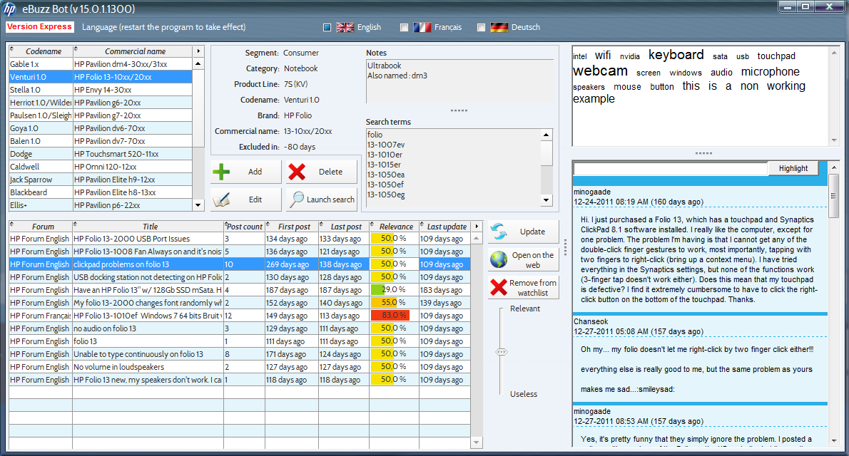

Figure - New eBuzz tool (Windev): Main interface

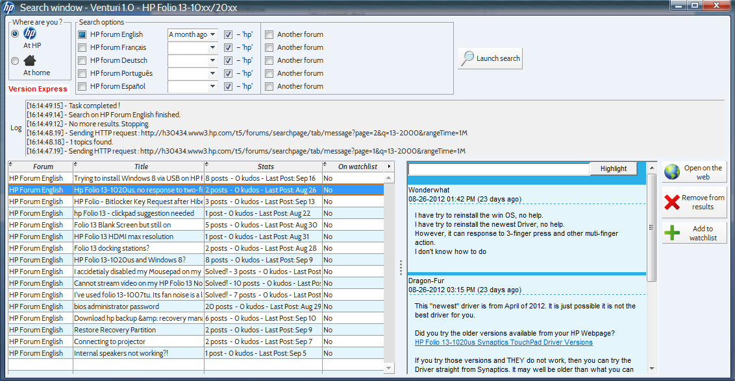

Figure - Main eBuzz tool (Windev): search interface

After having used this tool during a ten days test period, it appears that it really improves the forums monitoring process. The web crawling is in fact easier, as the opening of browser windows is not anymore needed. Another good result is the time spent to create and code the tool. In only two weeks, a basic version was already working, and after one month, the program was almost fully functional. The choice was made to only monitor HP hosted forums at the beginning, just to validate the efficiency of the new tool. The general feeling about this new tool was therefore quite positive.

However, some negative points were raised. First of all, the speed of the web crawling was quite slow. It was not a critical issue, but as the maximum runtime of the applications compiled with Windev trial version is one hour, it happened that the program closed before having read all the results for a specific search. Furthermore, a concern about the maintainability of the tool was raised. As I won’t stay at HP during all my life, at least not at the same position, it is mandatory to have the ability to easily found another people able to modify and improve it. And it is not the case for a tool coded using Windev.

Even if its efficiency has been recognized the decision was finally taken not to use Windev anymore to develop the monitoring tool. The solution offering the more flexibility, easy maintainability and ease of coding was the PHP-JavaScript-HTML-CSS-MySQL one. The role of each of these 5 programming and markup languages is the following:

* PHP: A server-side programming language, which generally HTML pages. It can read contents from another websites, as well as accessing MySQL databases.
* MySQL: The easiest and most common free database engine which can be used with PHP
* HTML: A markup language which contains the contents of a web page. It is live interpreted by web browsers to display pretty web pages. The figure xx shows the difference between an HTML webpage versus the same page styled with CSS.
* CSS: The essential complement of HTML to style user-friendly webpages
* JavaScript: A client-side programming language interpreted locally by the web browsers, which enables among other things to dynamically modify a part of a webpage, without having to reload it entirely. JavaScript can call directly PHP scripts to make operations on a database, for example.

In our case, the server which will run the PHP scripts will be the same than the client one. This can be achieved by running an Apache web server on this computer. The new monitoring tool, recoded with PHP and JavaScript, is presented in the next part of this report.

#### Second versions of the new tool (PHP-JavaScript): results

Just after having started the coding of the new version of the tool, it appeared that a choice will have to be made about the compatibility of the tool. In fact, the new tool will be mainly coded in PHP and JavaScript, and will therefore look like a normal webpage and need an internet browser to be displayed. The problem here is that both CSS and JavaScript languages have been consequently improved in the last years, and that some internet browsers don’t implement these new features correctly. Making a tool fully compatible with all the internet browsers is therefore quite ambitious: to replace a feature missing on some browsers, dozens of code lines have to be written. In JavaScript, such code extensions are called polyfills. As Microsoft Internet Explorer (mainly its old versions, from 6 to 8) has a lot of features missing, it was decided to develop the new tool only for a recent, fully-featured and user-friendly web browser. Finally the browser used in the development process is Mozilla Firefox in its 12 and 15 versions.

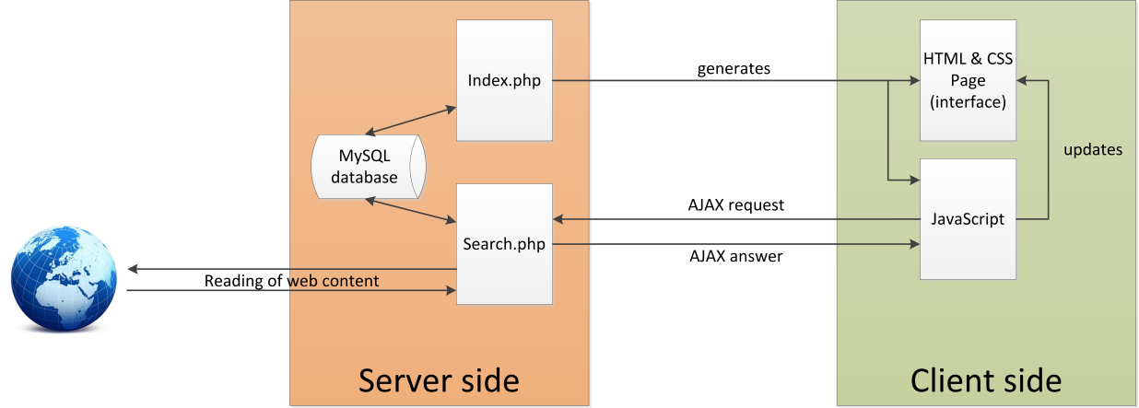

Figure - Simplified operating diagram of the new eBuzz tool

As explained in figure 14, the first PHP script will generate the user interface (an HTML & CSS webpage, plus some JavaScript). The JavaScript will enable the page to evolve dynamically. In fact, when the user will launch the search on the web, after having set some parameters, the script will launch a so-called AJAX (Asynchronous JavaScript and XML) request. This request will call another PH script, which will be responsible for browsing the forums and gathering information. Finally, this PHP script will answer to the AJAX request, and then the JavaScript will update the main HTML interface to display the results.

The figure 15 displays one page of the interface, during one search. The interface can be divided into five parts, numerated from 1 to 5 on the figure 15.

* The part n°1 is the navigation pane, which allows browsing the different sections of the tool. It just consists in HTML links.
* The part n°2 is the search settings pane. In this area can be selected the products and forum on which the search will be conducted. Some global or forum-specific parameters can also be defined. Finally, the button on the right launches the search.
* The part 3 is just an information area, which is automatically updated along the search process. The search can take long time, depending on the chosen parameters. So it is mandatory to have such information, to advise the user that the tool is still running.
* The part 4 displays in real time the results of the search. Thus, the first search results can be read before the end of the search process. Selecting a search result displays its full text on the preview pane. Once a search result is highlighted, some buttons allow adding this result on the monitoring list, to simply delete it, or to blacklist it.
* The part 5 is the preview pane, in which the whole content of a topic can be displayed, without having to open several internet browser windows, and having to wait for the pages to load.

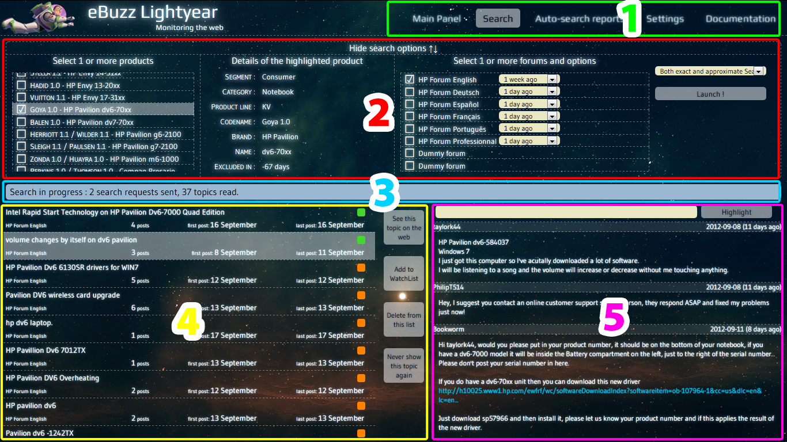

Figure - The search interface of the new eBuzz tool

The harder points encountered during the coding process were due to two difficulties:

* Discover, understand and learn some JavaScript functions, mainly to carry out Ajax requests
* Ensure the integrity of the database.

This second point may seem easy at first sight, but a lot of different scenarios have had to be examined. For example, what should be done…

* When a found topic has to be added in the database? If it is linked with one product? With several products? If it is linked to exact keywords? Generic keywords? Both? Was it already in the database for this product? For another product?
* When the user decides to remove a topic from the monitored topics list, if this topic is linked to one product? To several products?
* When the user removes one monitored product, what must be done with the linked topics? And if these topics are also linked to another products?
* When the user decides to blacklist a topic, if the topic is already in the monitored topics list, for the same product? For another product?
* Etc…

All these questions, as well as several others, have been taken into account each time where a transaction with the database is done.

Concerning the status of the development, the main interface of the tool is currently almost complete and fully functional. This interface is very similar to the one created with Windev, so no major improvements have been done here, except the gain of maintainability. However, the web crawling function of this new tool is, according to a dozen of testing sessions, between 7 and 9 times quicker than the Windev version. Finally, the structures chosen for both the tool and the database seem efficient, and do not posed any problem at all.

#### Global eBuzz results

Even if they don’t have all the scheduled features implemented, the new versions of the eBuzz tool are already functional. Using them, since the beginning of my internship, several thousands of forums topics have been read. Among these topics, around 100 different potential issues have been detected.

Regarding the products, 64 of them are currently monitored. In parallel to the 6 forums actually monitored with the tool, 9 other ones are monitored manually, and will be added to the tool in the future

Finally, 13 trending issues have been investigated:

* For 5 of them, data weren’t sufficient to confirm the issue
* 4 of them were already known at the 3LS, and corrective actions were already initiated
* The 4 remaining were deeply investigated

#### Future improvements

Even if the new tool is already functional, some features have still to be added, and some parts modified. First of all, the list of the monitored topics has to be redesigned, to display additional information. The settings page is still to be created too: for the moment, all the settings and products information have to be set manually in the database using phpMyAdmin interface. This process is time consuming and can generate errors; it must therefore be replaced by a dedicated page in the future.

Obviously, another forums currently monitored manually have to be added in the tool. Another feature that could be interesting is the adding of some statistics features, which will enable to discover trends more easily. However, the relevance of such functionality is still under discussion.

Last but not least, the speed of the tool can be improved. By tweaking some hidden settings in Mozilla Firefox, the number of simultaneous AJAX requests can for example be increased. Such settings require some testing, as their efficiency depends of the connection speed. Finally, some parts of the code can also be modified to increase the monitoring speed.

## Conclusion

In conclusion, I understood during these five months that the rapidity of the detection of deviations is crucial not only for the team I joined, but also for quality teams in general. Avoiding any loss of time can enable to save large sums of money. The communication within and without the team, as well as the information management are essential too.

More particularly about the eBuzz program, my work enabled the creation of a new unit capture process, although some minor points still need to be discussed. About the monitoring tool, its speed and its efficiency have been improved, however some features still have to be developed, and some forums added. It is with pleasure that I will complete this tool during my next months at HP.

Finally, I sincerely thank all the people I met at HP, and who helped me more or less during this internship. I am pleased to continue working with them during some additional months.

## Glossary

Hewlett-Packard

1LS: First level of support, generally located in each country where HP units are sold. It is mainly made up of the call centers technicians.

2LS: Second level of support, generally located in each country where HP units are sold. It is mainly made up of the repair lines engineers.

3LS: Third level of support, which is part of the *Global Business Unit*. Its engineers are dedicated to the deep failure analysis and to the development of corrective actions, to avoid the reappearance of issues.

CSS: *Customer Support and Services*, one of the services of PSG EMEA.

EMEA: *Europe, Middle East and Africa*. It is one of the three HP regions.

FCS: *First Customer Shipment*. It is the date where the first unit of a new model leaves officially the factory, to be delivered to customers.

PSG: *Personal System Group*. The business group dedicated to personal computers

QA&TCE: *Quality Assurance and Total Customer Experience*. Within PSG EMEA CSS, it is the team dedicated to ensure and to promote the quality of HP PCs.

Web design and programming

AJAX: *Asynchronous JavaScript and XML*. Group of techniques which enable web applications to send data to, and retrieve data from, a server, without interfering with the behavior of the existing page.

CSS: *Cascading Style Sheets*. A style sheet used for describing the look and formatting of an HTML web page.

HTML: *Hypertext Markup Language*. The markup language used to display web pages within an internet browser.

JavaScript: A scripting language, mainly used to create enhanced user interfaces and dynamic websites. JavaScript can also be used in other applications, for example in PDF documents.

MySQL: The world’s most used open source database management system.

PHP: *PHP Hypertext Preprocessor*. A server-side scripting language, which enables the production of dynamic web pages.

phpMyAdmin: A free and open-source tool dedicated to the administration of MySQL databases, directly within a web browser.

## Table of Figures

Figure 1 - Breakdown of HP revenue by segment and by region (first 2012 quarter data) 6

Figure 2 - HP current organization 7

Figure 3 - PSG EMEA partial organization 8

Figure 4 - Organization chart and nationalities of the members of the QA&TCE team 9

Figure 5 - The programs led by the Early Warning team 10

Figure 6 - eBuzz entire process 15

Figure 7 - Former eBuzz tool: issue tracking sheet 22

Figure 8 - Former eBuzz tool: topic tracking sheet 22

Figure 9 - Former eBuzz tool: list of monitored products 22

Figure 10 - Former eBuzz tool: search sheet, opening several browser windows, according to search terms 23

Figure 11 - Comparison of the languages considered for the development of the new eBuzz tool 27

Figure 12 - New eBuzz tool (Windev): Main interface 28

Figure 13 - Main eBuzz tool (Windev): search interface 28

Figure 14 - Simplified operating diagram of the new eBuzz tool 30

Figure 15 - The search interface of the new eBuzz tool 31

## Bibliography

General information

*Hewlett-Packard* article on en.wikipedia.org

Hewlett-Packard internal documentation

*EMEA Early Warning overview 2012*, PDF document

QA&TCE team SharePoint

Several financial documents

HP internal website

*1971-2011: 40 ans de presence en Isère*, promotional booklet edited for HP Grenoble and HP l’Isle d’Abeau employees

Web design and programming – cheat sheets

*Mémento XHTML – Balises courantes*, PDF document, www.eric-bellot.fr/files/memento_balises_html_0.pdf

*Mémento XHTML – Formulaires*, PDF document, www.eric-bellot.fr/files/memento_xhtml_formulaires_0.pdf

*Mémento CSS 2.1 – Bases et mise en forme*, PDF document, www.eric-bellot.fr/files/memento_css.pdf

*HTML 5 quick reference guide*, PDF document, veign.com

*CSS 3 quick reference guide,* PDF document, veign.com

*Emezeta PHP Card – Reference cheat sheet*, PDF document, http://www.emezeta.com/weblog/emezeta-php-card-v0.2.zip

*MySQL cheat sheet*, PDF document, http://www.addedbytes.com/download/mysql-cheat-sheet-v1/pdf/

*Javascript Quick Reference Card*, PDF document, http://www.explainth.at/downloads/jsquick.pdf

*JavaScript and Browser Objects Quick Reference, Javascript Bible 6th Edition, Appendix A*, PDF document, http://www.dannyg.com/ref/jsquickref.html

*JavaScript cheat sheet*, PDF document, http://www.addedbytes.com/download/javascript-cheat-sheet-v1/pdf/

*Regular expressions cheat sheet*, PDF document, http://www.addedbytes.com/download/regular-expressions-cheat-sheet-v2/pdf/

Web design and programming – Complete courses

*Dynamisez vos sites web avec Javascript !*, http://www.siteduzero.com/tutoriel-3-309961-dynamisez-vos-sites-web-avec-javascript.html

*Concevez votre site web avec PHP et MySQL*, http://www.siteduzero.com/tutoriel-3-14668-concevez-votre-site-web-avec-php-et-mysql.html

Web design and programming – Code samples

*Nanoscroller.js*, http://jamesflorentino.github.com/nanoScrollerJS/

*Searchhi.js*, http://kryogenix.org/code/browser/searchhi/

Web design and programming – General help

http://www.siteduzero.com/

http://www.alsacreations.com/

http://www.developpez.com/

http://www.codes-sources.com/ and child websites

http://www.php.net/

And many others…